# Landing Pages Integration with Zoho CRM

Step 1 . Borrower fills in the Quick quote – selects amount and term from sliders; enters email and phone number

*The way this slider / email and phone number should work needs to be the same as the one that currently exists in main web site under the Credit / Eligibility option – the Monthly Repayment and Total Amount Payable should not be displayed until the ‘Get a Quote’ button is clicked.*

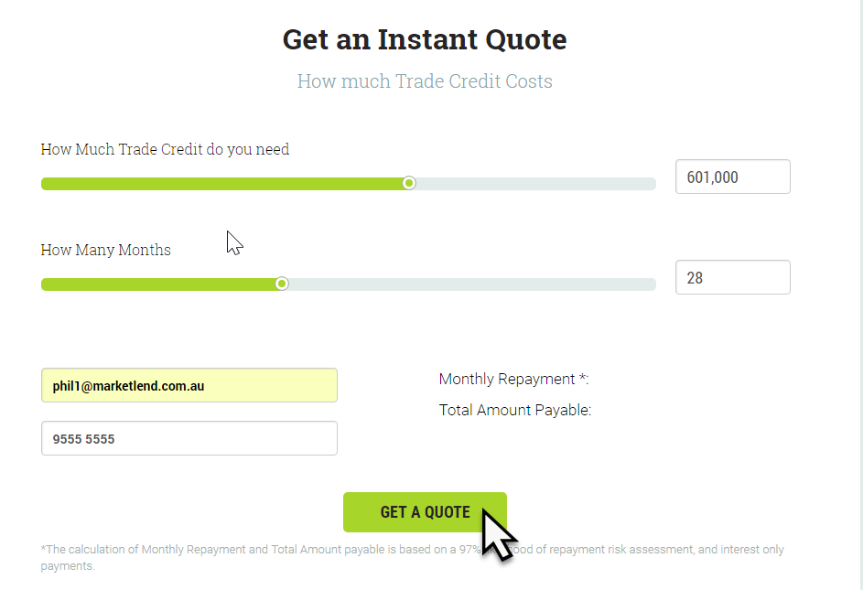

*This is the Instant Quote section on the existing Eligibility page on main web site.*

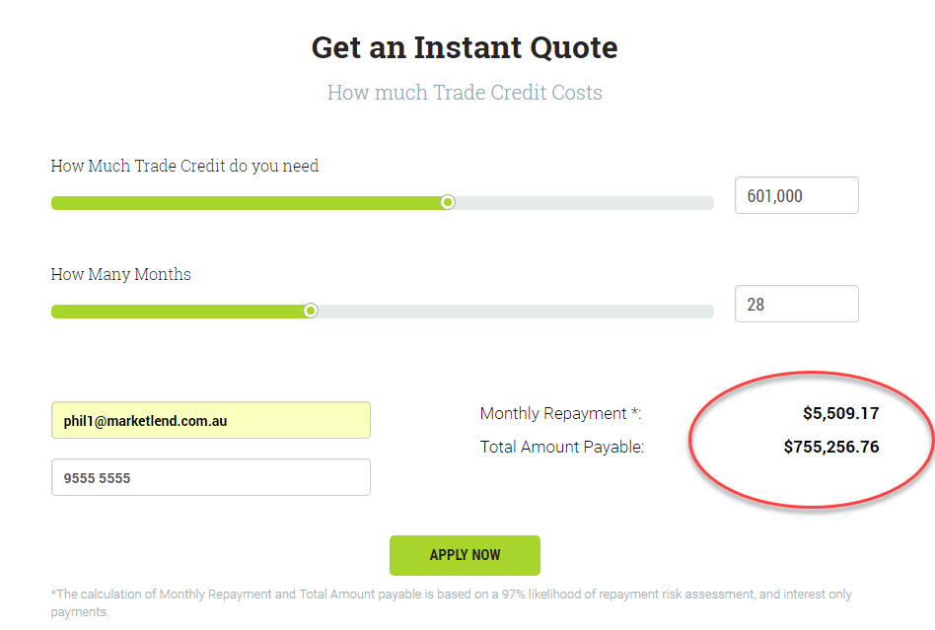

*Only once user has clicked the ‘Get Quote’ button does the payable amounts display.*

WHAT CHANGES ARE NEEDED?

1. Keep the layout of the Instant Quote same as below – but change behaviour so that screen behaves same as Eligibility quote screen – ie button says ‘Get Quote’ – when click (and email and phone number entered) display quote amounts.
2. You need to change the ‘How Much’ slider so that Maximum value is $1,000,000
3. Fix the font and display of the amounts in ‘How Much” and ‘How Long’ – amount should display with thousand separators and in correct font (Roboto)
4. After the user gets the Quick Quote the button needs to change to ‘Apply Now’

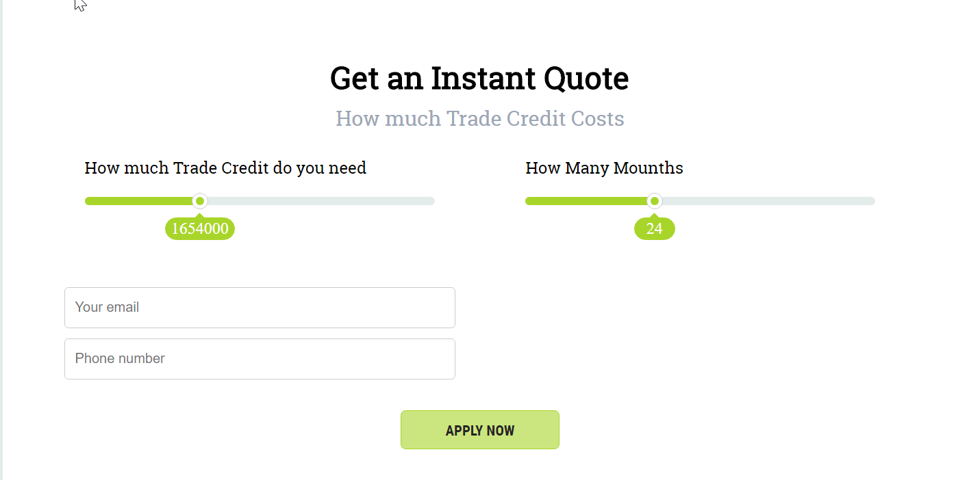

Step 2 – Apply for personalised quote

1. When user clicks on any of the ‘Apply Now’ button on the page there should be a Pop-up which is the same as the one already available on the Eligibility page from the “Get a Personalised Quote” button. If the user has already filled in phone number and email address in the quick quote screen then these should be carried over to this form.
2. When the form is submitted all details should be stored in Zoho (see mapping below)

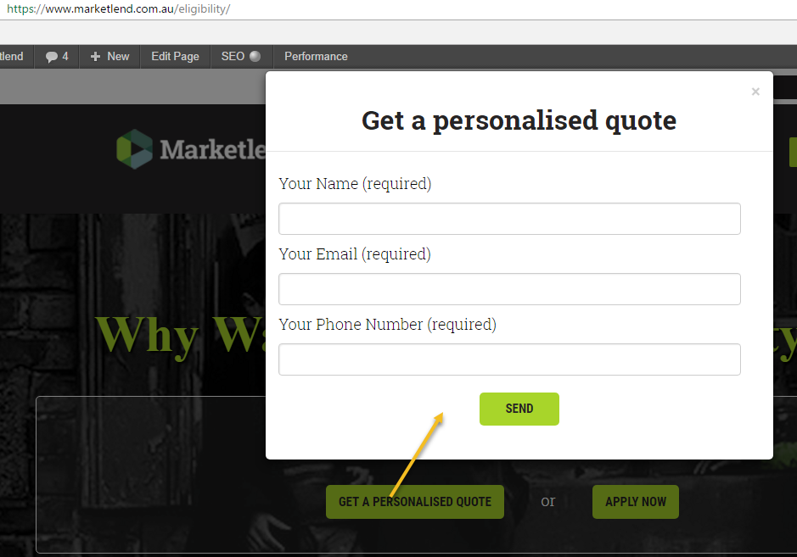

Step 3 . Update form information to Zoho. Form data will be used to create a new “Potential” in Zoho with the following attributes:

|  |  |
| --- | --- |
| Zoho Field – Potential | Source |
| Potential Owner | Default to Administrator Marketlend |
| Email 1 | Email entered in web form |
| Member Source | Default to “Google Ads” |
| First Name / Company Name | Name entered in web form |
| Phone 1 | Phone Number entered in web form |
| Closing Date | Default to Today’s date + 3 days |
| Stage | Default to “Qualification” |

Step 3. Acknowledgement

When enquiry is submitted display a pop-up message saying “Thank you for your interest in Marketlend business lending. A representative from Marketlend will phone you soon.”

When the pop-up message is closed then user will remain on the page where they entered the enquiry from.

A confirmation email will also be sent to the email address that was entered in the enquiry.

*Content and layout of the conformation email will be provided soon.*